Constructing Training Images for Veins and Using Them in Multiple-Point Geostatistical Simulation.

Jeff B. Boisvert Steve Lyster (corresponding author) Clayton V. Deutsch
Graduate Student Graduate Student Professor
jbb@ualberta.ca lyster@ualberta.ca cdeutsch@ualberta.ca

Centre for Computational Geostatistics
Department of Civil & Environmental Engineering
University of Alberta
3-133 Markin/CNRL Natural Resources Engineering Facility
Edmonton, Alberta, Canada T6G 2W2
+1 (780) 492-3337

Abstract
The current trend in geostatistical research has been towards using multiple-point statistics (MPS) to capture spatial information beyond the two-point variogram. This allows for the reproduction of complex features and ordering of rock types in geostatistical simulations. Inferring MPS requires a representative and exhaustive training image (TI). TIs are difficult to obtain. Until now MPS have been used primarily in petroleum applications due to a lack of mineral deposit TIs. A methodology to create TIs for vein type deposits is presented. These TIs are generated by mimicking the vein formation process. TI generation begins with a fracture model that is flow simulated to represent the flow of the ore-bearing fluid through fractured rock. Areas of the model that have a high flow correspond to veins, representing a high flow of ore-bearing fluid at the time of deposition. Once appropriate TIs have been generated they may be used in MPS simulation. An initial image is generated with two-point statistics derived directly from a TI; then, the realization is iteratively perturbed using multiple normal equations and the covariances between MP events to determine conditional probabilities at each location. The indicator value at each location is updated with a Gibbs sampler. The proposed approach results in reproduction of the curvilinear features seen in the TI, orientations and sizes of veins, and reproduction of lower-order statistics such as the variogram. To test the reproduction of high-order relations, the MP histograms and distributions of runs are compared between the TI and realizations.

Introduction
A brief overview of the basic geological processes that form veins will give the reader the necessary background to assess how well the generation of TIs reproduces these processes. Different types of multiple-point statistics are presented that will be used to assess how well the multiple-point realizations reproduce the statistics of the parent TI. A review of other available algorithms utilizing multiple-point statistics will highlight some of the previous work that has occurred in this area.

Vein Type Deposits
The methodology used to generate vein type TIs mimics the geological processes that form veins; therefore, a brief review of the formation of veins is required. Veins will form when an ore-bearing fluid flows through an area and deposits a mineral of interest in fractures. This will occur when the path of highest permeability is through the faults rather than through the interconnected pore spaces in the host rock (Guilbert and Park, 1996). If the chemical and physical conditions are appropriate the mineral contained in the ore-bearing fluid will precipitate out of solution and form a deposit along the fracture plane. It is the movement of the ore-bearing fluid through fractured rock that will be mimicked by the proposed mythology rather than the physical and chemical processes that cause precipitation, see Guilbert and Park (1996) for a detailed explanation of the precipitation process.

Multiple-Point Statistics
There are a variety of multiple-point statistics available. A multiple-point statistic is any statistic that is taken between two or more data points. The distribution of runs and the multiple-point histogram will be used to determine how well the realizations generated by the Gibbs methodology reproduce the statistics of the parent TI.

The distribution of runs is a 1-D statistics that is calculated by counting the length of adjacent categories in a string of data. For example, see Figure 1.

Figure 1: Calculating the distribution of runs for a string of categories.

The lengths of adjacent categories are used to generate the distribution of runs. In this example the distribution would consist of 1 run of length four, 1 run of length three, 3 runs of length two, and 3 runs of length one. Moreover, the cumulative distribution of runs considers that each run contains all smaller length of runs. A run of length four contains 2 runs of length three, 3 runs of length two and so on. For this example the cumulative distribution of runs would consist of 1 run of length four, 3 runs of length three, 8 runs of length two, and 16 runs of length one.

The traditional histogram counts the frequency of times a particular continuous variable falls in a bin, or counts the frequency of times that a particular indicator variable occurs. The multiple-point histogram counts the frequency of times a multiple-point configuration occurs. Consider a 4 point configuration that could take two different values, there are a total of 16 (2⁴) unique configurations, see Figure 2.
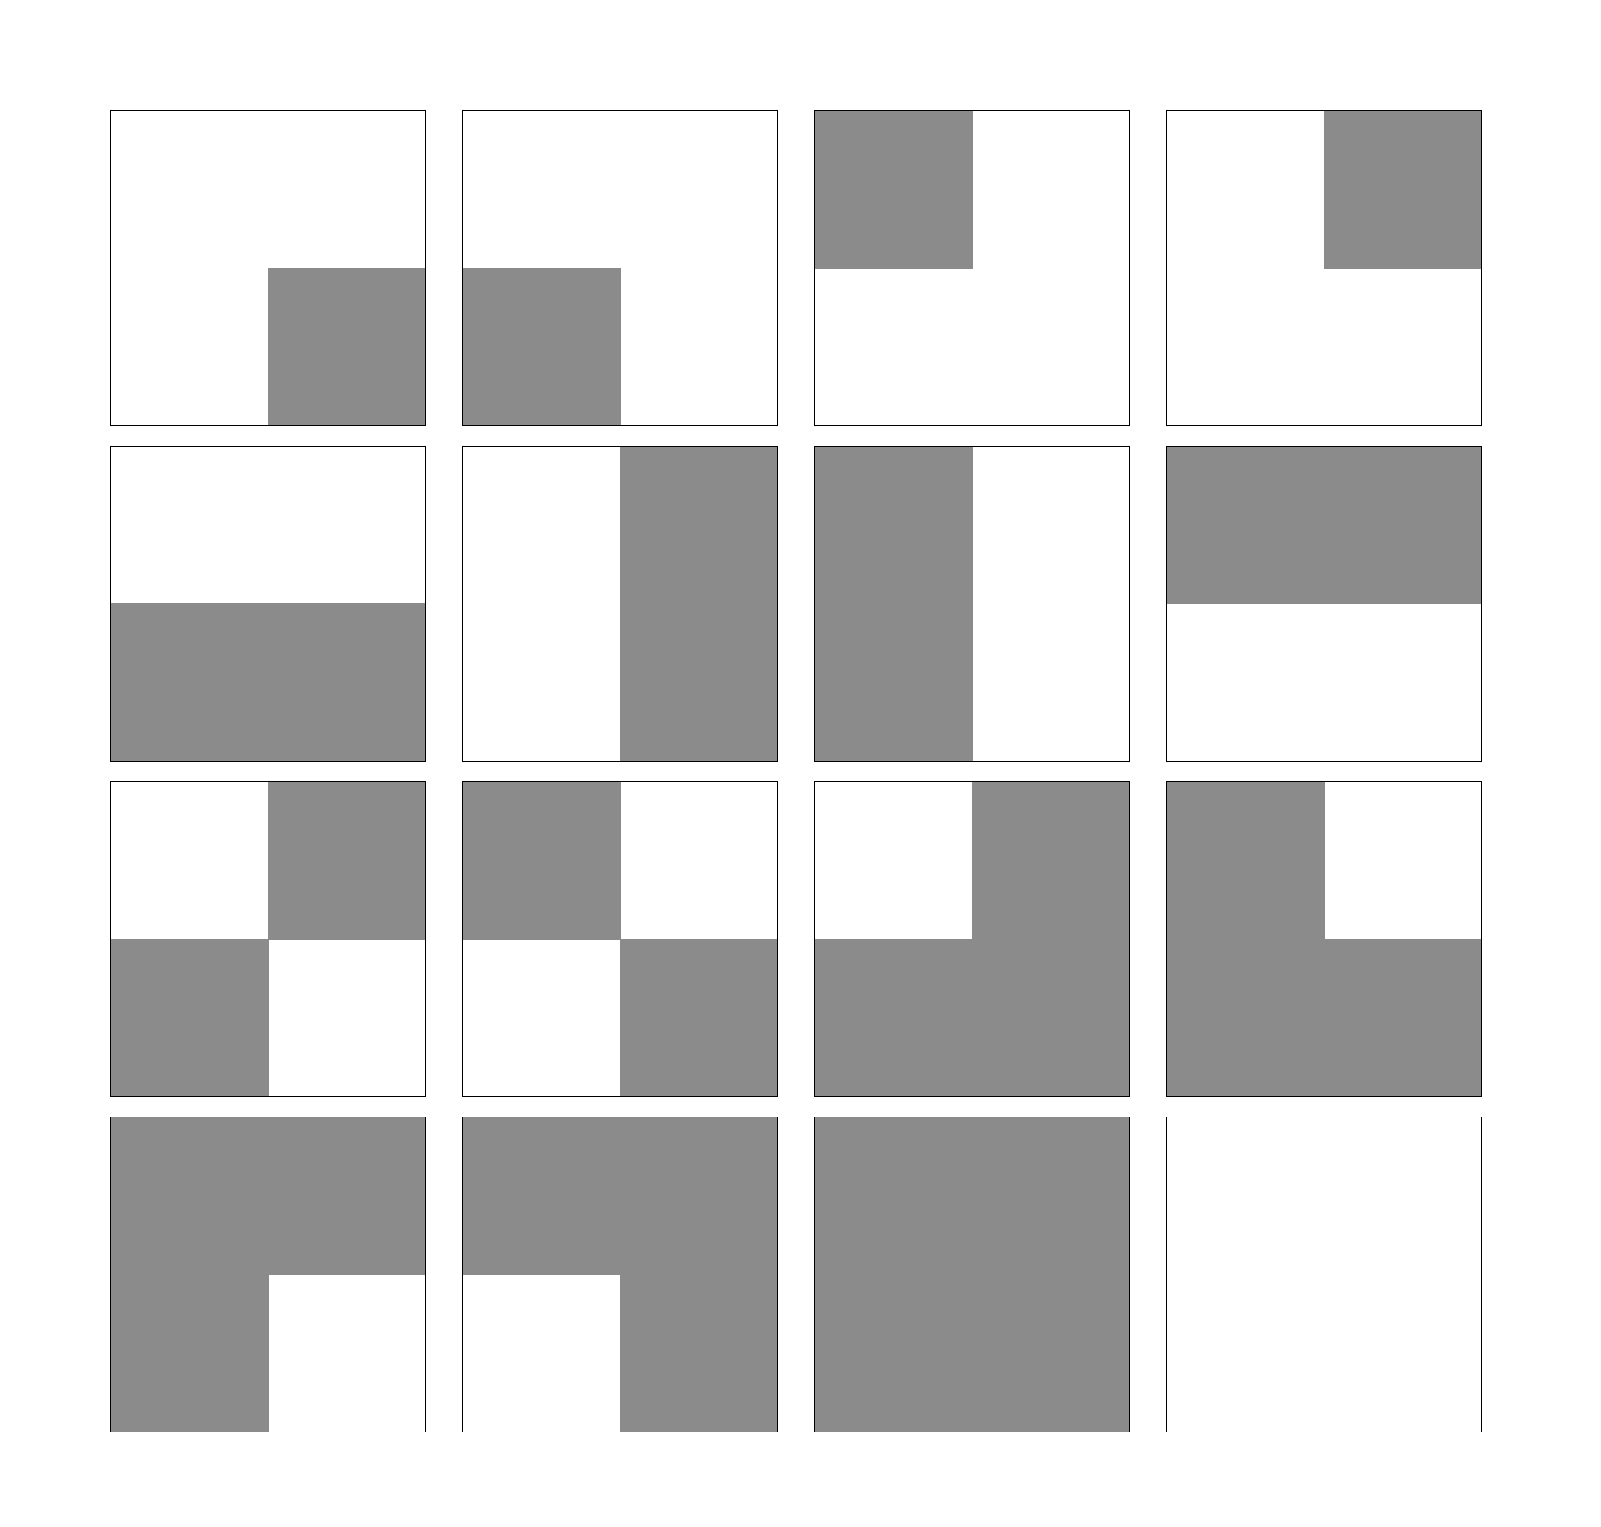
Figure 2: All possible arrangements of a 4 point configuration with two categories.

Considering this four point configuration, or template, the multiple-point histogram for a gridded image can be calculated. The number of times that each configuration in Figure 2 occurs in the image is counted and the bins of the histogram correspond to the different configurations. Consider the image and its corresponding multiple-point histogram in Figure 3.

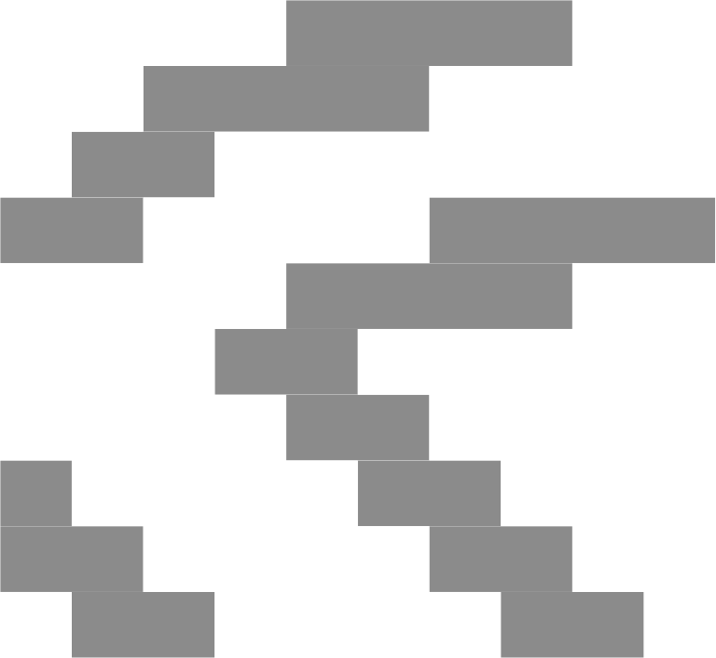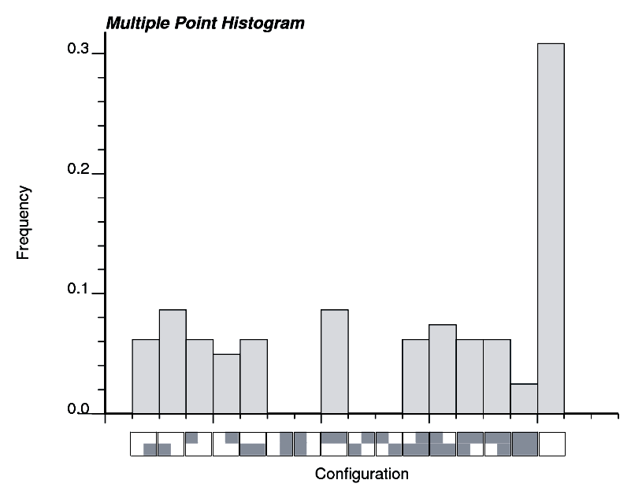

Figure 3: Left – An example of a TI. Right – The multiple-point histogram for the example TI.

Note that the ordering of the bins in Figure 3 is entirely arbitrary, so long as the bins are ordered consistently there is little confusion. Considering a larger template or more categories significantly increases the number of bins in the multiple-point histogram, making visualizing the multiple-point histogram for large templates challenging. There is no limitation on the size of the histogram or template used other than the computational effort required to deal with the large number of configurations.

MPS Algorithms
There have been several methods proposed for reproducing MPS in realizations. The first was the single normal equation (SNE) algorithm (Guardiano and Srivastava, 1993) which is the most fully developed method to date (Strebelle, 2002). The idea behind the SNE approach is to directly infer conditional probabilities from a TI using Bayes’ law (see equation [1]), and then draw a simulated facies from the conditional distribution as in Figure 4.
$P\left(A|B\right)=\frac{P\left(A∩B\right)}{P\left(B\right)}$
[1]

1
2
3
?

Figure 4: An example of the SNE methodology for three conditioning points and three potential values (white, grey, and black).

Simulated annealing has been used for reproduction of MPS (Deutsch, 1992). This algorithm is a general optimization method for minimizing any desired objective function; in the case of MPS simulation the objective is the difference between the MP histograms for the TI and the realization. Other statistics could also be included in the objective function, such as the variogram or univariate statistics.

Neural networks have also been used for MPS simulation (Caers, 2001); like simulated annealing, this is an iterative method. The neural network approach uses pattern recognition trained to the TI to reproduce high-order structures. Both the simulated annealing and neural network MPS methods are Markov chain Monte Carlo algorithms, and are variations of the Metropolis-Hastings algorithm (Metropolis et al, 1953).

In this paper, a novel MPS simulation method is proposed using a Gibbs sampler algorithm (Geman and Geman, 1984). The Gibbs sampler is also a variation of the Metropolis-Hastings algorithm and is therefore an iterative approach.

Methodology
The proposed methodology can be used to generate TIs from fracture models for vein type deposits, simulate with MPS to reproduce curvilinear features otherwise inaccessible by traditional geostatistical methods and to rank these realizations based on how well they reproduce the statistics of the parent TI.

TI Generation: Vein Type Deposits
TIs will be created for vein type deposits by mimicking the geological process that produce veins. Veins are formed as ore bearing fluids pass though fractures; therefore, a fracture model is required. This fracture model must be geologically realistic and contain the desired curvilinear features such as the direction of anisotropy, fracture spacing, fracture length fracture orientation etc. There are a variety of techniques that could be used to generate the required fractures, such as seeding fractures and propagating them based on insitu stresses, randomly placing fractures in a model and drawing their properties from distributions, or using a model of a similar area that has been mapped in detail. A fracture model provided by Srivastava (2002) will be used to demonstrate the proposed methodology, see Figure 5.

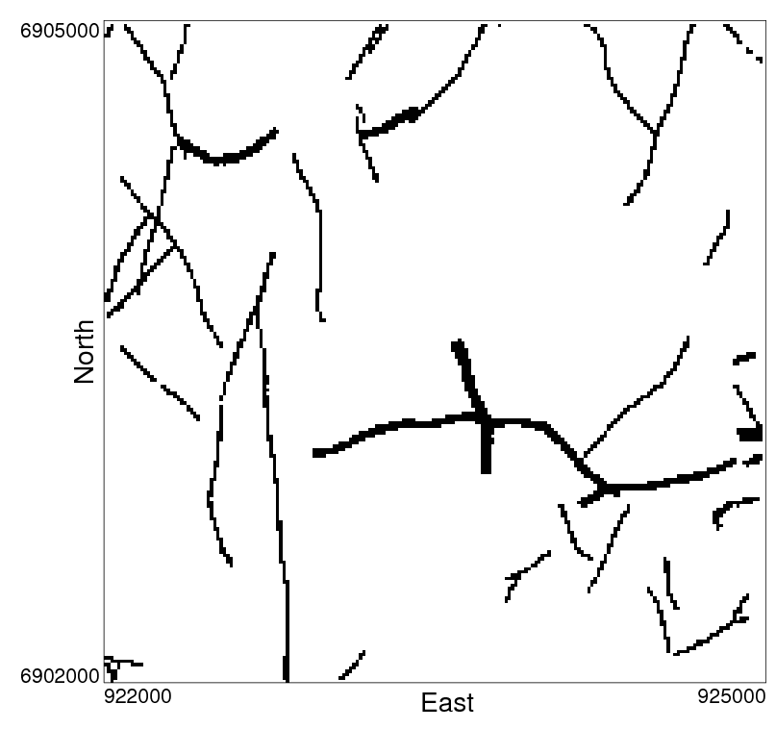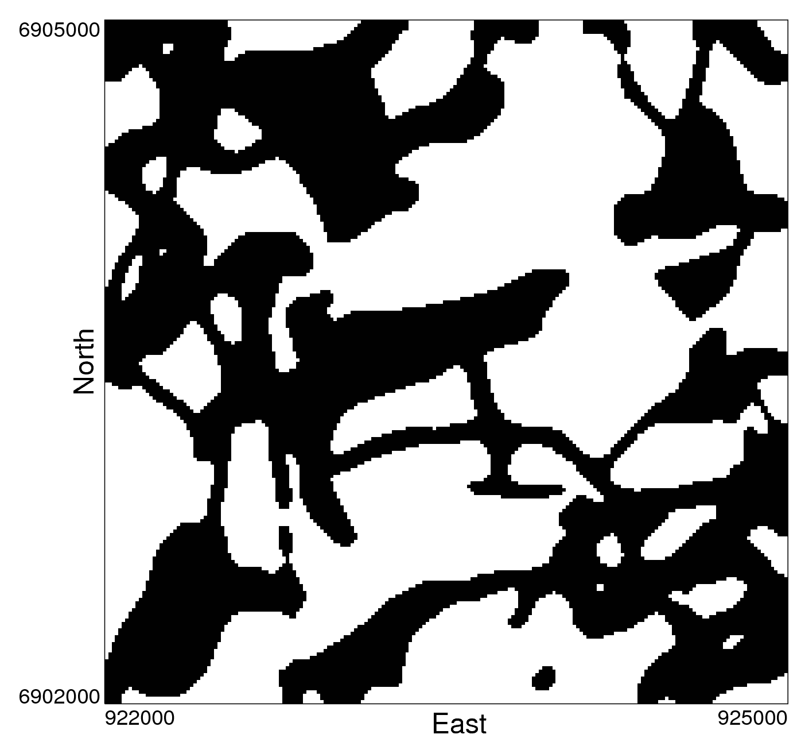
Figure 5: Left – Plan section of the original fault model, this is 4% of the entire fracture model provided by Srivastava (2002). Right – Cross section of final vein TI using an aspect ratio of 10:1 (veins:hostrock permeability).

Once a fracture model is available a TI can be created by modeling the flow of the ore bearing fluid. This is done using FLOWSIM (Deutsch, 1987) although any flow simulator could be used. FLOWSIM is a steady state flow simulator and requires a permeability model. The permeability model is created by assigning a constant high permeability to the fractures in the fracture model and a low permeability to the host rock. The magnitude of the permeability values can be varied to generate TIs with different characteristics. FLOWSIM applies a pressure gradient in one of the principle directions and solves for the pressure in each cell in the model. From the pressure difference between cells and Darcy’s law the flow rate between all adjacent cells can be calculated:
$Q=\text{AK}\frac{Δp}{Lρg}$
[2]

Of interest is the total flow though each cell and this can be found by summing the flow rate across each face for all blocks. Note that FLOWSIM only considers a pressure gradient across the model in one direction. To mimic the flow of an ore bearing fluid through the fracture model two simulations are performed with the pressure gradient in the X direction and the Y direction. A third simulation with a gradient in the Z direction could be also be included. Figure 6 shows how the flow rate is calculated for a block with the gradients in the X and Y directions.

Figure 6: Determining the total flow rate in a block (Q) as a summation of the flow rates when the gradients are applied in the X and Y directions (Q_{x} and Q_{y}).

This calculation does not generate the actual flow through the block but will accurately represent areas that have a high flow rate, which are then deemed veins. This results in a binary facies model with the distinction between vein and non-vein. To increase the geological realism of the TI a smoothing algorithm, MAPS (Deutsch, 1998) is applied, see the final TI in Figure 5.

This methodology can be used to create multiple TIs for the same fracture model by varying fundamental parameters. The threshold on the flow rate can be increased to generate thick vein structures and the aspect ratio (veins:hostrock permeability) can also be altered to generate TIs with the desired site specific characteristics.

Generating Realizations: Gibbs Sampler
Simulation of the vein deposits will proceed using a new MPS method. This method utilizes a Gibbs sampler algorithm. The idea behind the Gibbs sampler is to resample variables in a joint distribution conditional to all other variables; after some number of resamples has been performed, the final “state” (values) approximates a sample from the joint distribution of all variables. This method has the advantage of not requiring the marginal or joint distributions to be known, but relies only on the conditional distributions. For MPS simulation, these conditional distributions may be inferred from the TI.

In the context of geologic simulation, each variable is the rock type occurring at a location; the marginal distributions are the probabilities of all facies at each location, and are unknown but of interest; and the joint distribution is the probability of every combination of rock types that are possible in the simulation field. It is impossible to determine the full joint distribution analytically, as it is far too complex and the dimension of the problem makes it unreasonable to consider every combination of rock types and calculate the probability of every combination. Given this fact, the joint distribution may be approximated by taking a number of samples from the joint distribution (i.e. realizations) which may be deemed equally probable. The Gibbs sampler may be used to approximate these samples and produce realizations by using only conditional probabilities.

The most important consideration in this method is how to determine the conditional probabilities. In reality the true conditional probabilities are unknown and may only be approximated. How to estimate the conditional distribution at every location is therefore a modeling decision that must be made. Any method desired could be used, but the final realization will reflect the selection. For example, a Gibbs sampler using indicator covariances and kriging will reproduce the two-point statistics. In this case we want to use MPS to reproduce the curvilinear features of the TI.

To estimate the conditional probabilities, the concept of multiple-point events (MPEs) is proposed. Each MPE is an arrangement of N points near the location currently being resampled. The initial images used in iterative MPS simulation will not honour MPS; because of this, there are many mismatches and patterns that are not seen in the TI. By considering M MPEs rather than a single event, it is hoped that the effect of these mismatches may be minimized. If a MPE has some arrangement of facies that does not occur in the TI this event may be disregarded and the remaining MPEs will hopefully provide enough information to accurately estimate the conditional distribution. An example of a pattern that could cause inference problems, as well as an arrangement of four-point events that could potentially solve this issue, are shown in Figure 7.

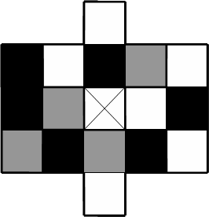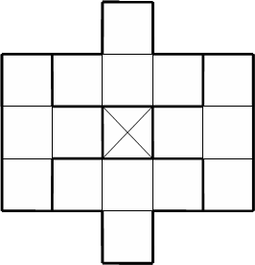
Figure 7: An arrangement of facies that may not be contained in a TI (left) and could cause problems when inferring conditional probabilities; four-point MPEs (right) that could be used to divide the template into four sections and hopefully avoid the problem.

Using M MPEs as information, the conditional probability of each rock type at a location may be approximated with a linear estimator:
$P^{}\left(k\right)=\sum_{i=1}^{M}{λ_{i}^{k}⋅\left[I\left(E_{i}\right)−P\left(E_{i}\right)\right]}+P\left(k\right)$
[3]

Where:
$P^{}\left(k\right)$ is the estimated probability of facies k at the current point;
$λ_{i}^{k}$ is the weight given to MPE i for the probability of k;
$E_{i}$ is one of the MPEs near the current point;
$I\left(E_{i}\right)$ is the indicator of the MPE; it is 1 for all events considered;
$P\left(E_{i}\right)$ is the global probability of E_{i}, also denoted as f_{j};
$P\left(k\right)$ is the global probability of k, also denoted as P_{k}

Minimizing the variance of this estimator then leads to the set of equations:
$\sum_{j=1}^{M}{λ_{j}^{k}⋅\text{Cov}\left\{E_{i},E_{j}\right\}}=\text{Cov}\left\{E_{i},k\right\}$$i=1,…,M$
[4]

Where the multiple-point covariance may be defined as

$\text{Cov}\left\{E_{i},E_{j}\right\}=E\left\{\left[I\left(E_{i}\right)−P\left(E_{i}\right)\right]⋅\left[I\left(E_{j}\right)−P\left(E_{j}\right)\right]\right\}=P\left(E_{i}∩E_{j}\right)−P\left(E_{i}\right)⋅P\left(E_{j}\right)$[5]

If the estimator in equation [3] uses only a single point per event, then the process shown in equations [3] through [5] simplifies to traditional two-point indicator Kriging. Also, if only a single MPE is used then solving for the optimal weight in equation [4] leads to the single normal equation and Bayes’ law. These two results suggest that the method proposed is valid, and is a general case of indicator kriging and multiple-point estimation.

Using the proposed Gibbs sampler workflow, 50 realizations were produced using the TI in Figure 5. The size of the simulated models is the same as the size of the training image, 200 x 200 x 30 for a total of 1.2 million cells. A slice from one realization created by two-point indicator simulation is shown on the left of Figure 8; on the right is a slice from the final realization honoring MPS. The realizations were created using ten 6-point MPEs, looping over all locations ten times. Simulating 50 realizations took 14:58:46 on a dual processor 3.2 GHz PC with 3.0 GB of RAM.

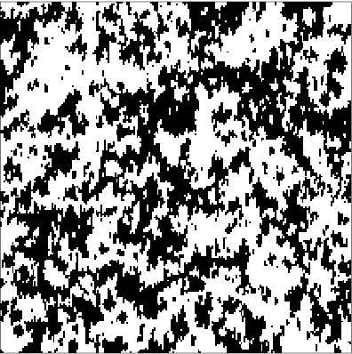
Figure 8: Left – Slice from a realization of two-point indicator simulation using the variogram from the TI shown in Figure 5. Right – Slice from a realization of MPS simulation with the proposed Gibbs sampler workflow, using the TI in Figure 5.

For comparison purposes, fifty realizations were also created using the SNESIM program (Strebelle, 2002). A slice from one realization is shown in Figure 9. This is not meant to be a critical comparison of the two methods; the SNESIM realizations were performed to give a control basis for the proposed algorithm as the SNE approach is the most widely accepted MPS simulation method.

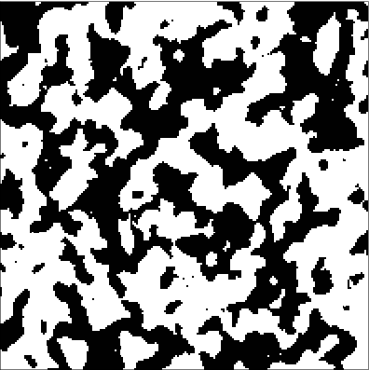
Figure 9: A slice from a realization produced using the SNESIM program (Strebelle, 2002).

Results and Discussion

Checking Realizations by Traditional Methods
The traditional method of validating simulated models usually involves comparing the reference variogram to the variograms of the realizations. Although the goal of the proposed MPS simulation method is to reproduce the high-order structure seen in the TI, lower-order statistics such as the histogram and variogram are important. Poor replication of the variogram may indicate a problem with the realizations; comparing the two-point statistics is a fast and easy way to check for issues. Also, the variogram is such a widely accepted measure of spatial structure that its exclusion in nearly any study would likely be questioned.

Shown in Figure 10 are the variograms for each of the three simulation methods used: two-point indicator simulation (left), the SNESIM program (centre), and the proposed new MPS algorithm (right). The variograms in the X, Y, and Z directions are shown from the top down respectively; the reference TI variogram is a solid black line, and each of the 50 realization variograms for each method is represented by a dashed gray line. The most notable feature of the variogram reproduction is that the two-point simulation actually reproduced the target TI variogram worse than both MPS methods; the additional randomness seen in the higher variogram values is a feature of using the SIS method which maximizes the entropy of the realization while still honouring the spatial covariance. The proposed algorithm best reproduces the TI variogram, and also has the largest range of variogram uncertainty; this result suggests that at least the variogram cannot be used to invalidate the results of MPS simulation.

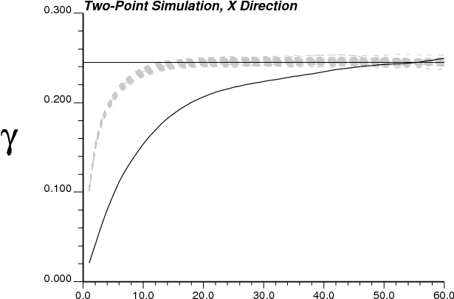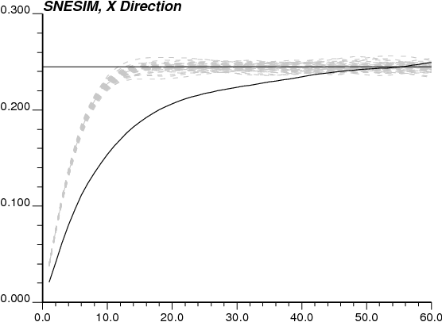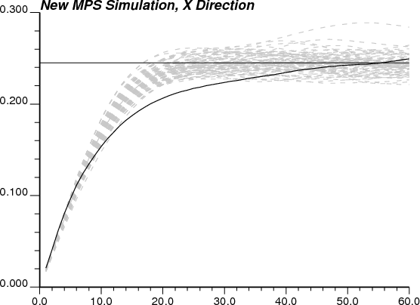

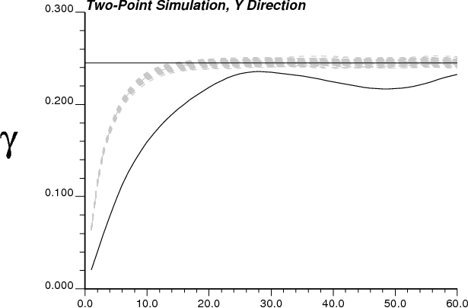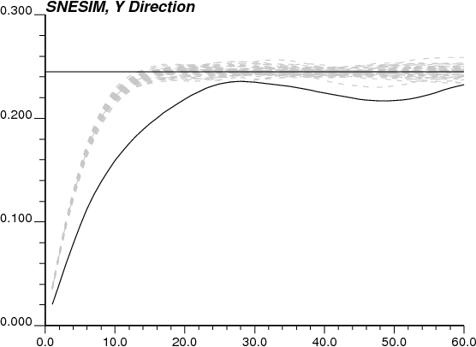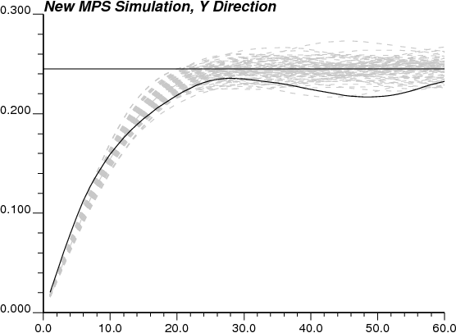

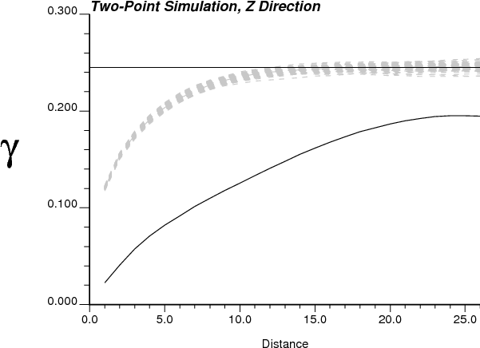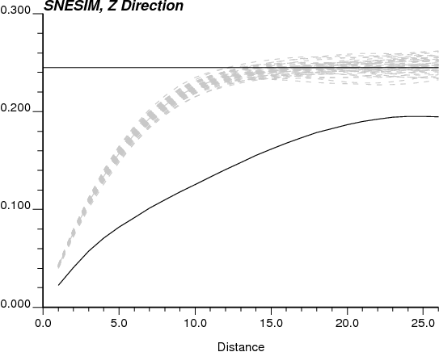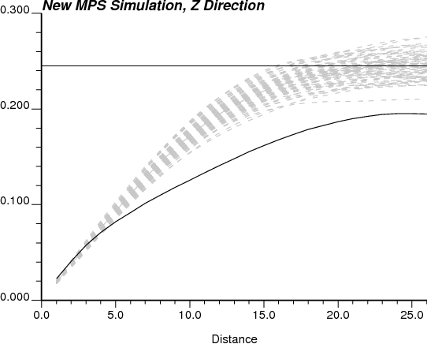
Figure 10: Variogram reproduction for 50 realizations for each of the three simulation methods (two-point SIS, SNESIM, and the proposed MPS algorithm). All three principal directions are shown. The solid black lines are the reference variograms from the TI; the gray dashed lines are for the realizations.

Checking Realizations with MPS
When performing MPS simulation it is important to check that the curvilinear features present in the TI are reproduced in the realizations. This is akin to checking histogram and variogram reproduction with Gaussian based techniques. Two comparison statistics will be used to determine how well the Gibbs sampler reproduced the MPS of the parent TI. First, the distribution of runs will be compared followed by a comparison based on the multiple-point histogram. The MP histogram is difficult to visualize because of the potential number of bins and the fact that adjacent bins are unrelated; however, the MP histogram contains more information than the distribution of runs making it an important MPS to consider.

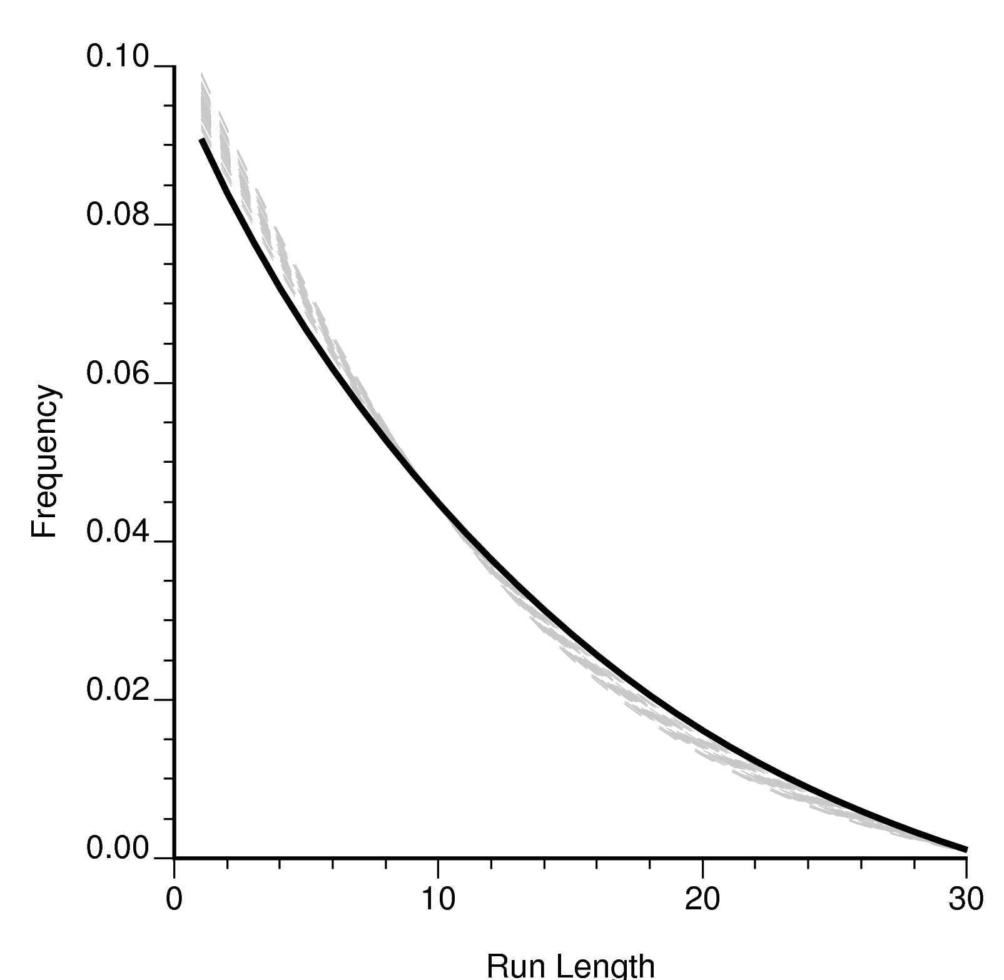
Figure 11: Distribution of runs for 50 MPS realizations (gray dashed lines) and the original TI (solid black line) in the vertical direction.

The distribution of runs can also be calculated in the X or Y directions and compared to the TI. Rather than just a visual comparison of the distribution of runs, a numerical comparison can be made. It is useful to assign a single number that represents how similar the realizations are to the original TI. This has the benefit of providing a ranking measure that can determine which MPS realizations better reproduce the curvilinear features of the parent TI. The proposed ranking measure is a simple summation of the difference between the distributions for each length of runs, see equation [6]:
$\text{difference}=\sum_{l=1}^{n}{\left|f_{l}^{}−f_{l}^{\text{**}}\right|}$
[6]

Where $f_{l}^{}$is the frequency of runs of length l for the TI, $f_{l}^{\text{**}}$is the frequency of runs of length l for the realization and n is the maximum length of runs.

This difference measure can be used to rank all MPS realizations, see Figure 12. The runs distribution is calculated in the X and Y directions and combined to generate the difference score. Runs distribution is an excellent multiple-point statistic if presented with sparse data; however, because realizations are being compared to TIs there are many data points available. In this situation the MP histogram is well informed and can be used to compare realizations. A similar equation is used to compare the MP histogram but the difference taken is between the frequencies of the bins, see equation [7]:
$\text{difference}=\sum_{i=1}^{n}{\left|f_{i}^{}−f_{i}^{\text{**}}\right|}$
[7]

Where $f_{i}^{}$is the frequency of the i^{th} MP histogram bin for the TI, $f_{i}^{\text{**}}$is the frequency of the i^{th} MP histogram bin for the realization and n is the maximum number of bins in the histogram.

This difference measure is also used to rank realizations and is shown in Figure 12. Because of the large number data available a 3x3x2 template was used to compare the realizations. Note that this results in a total of 2¹⁸ (262,144) bins and examining a 3x3x3 template would increase the number of bins to 134,217,728.

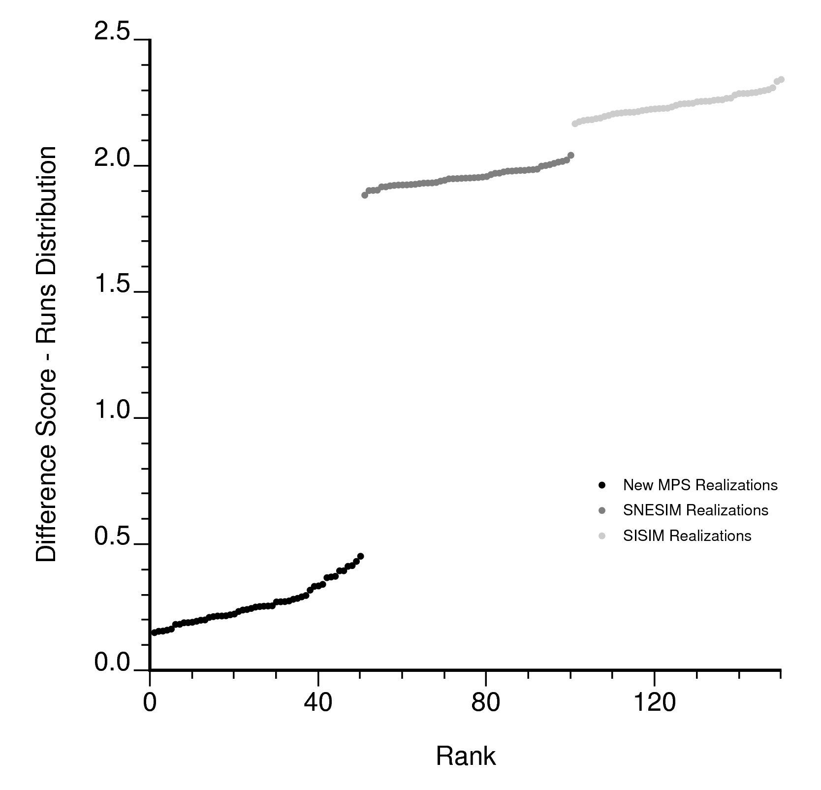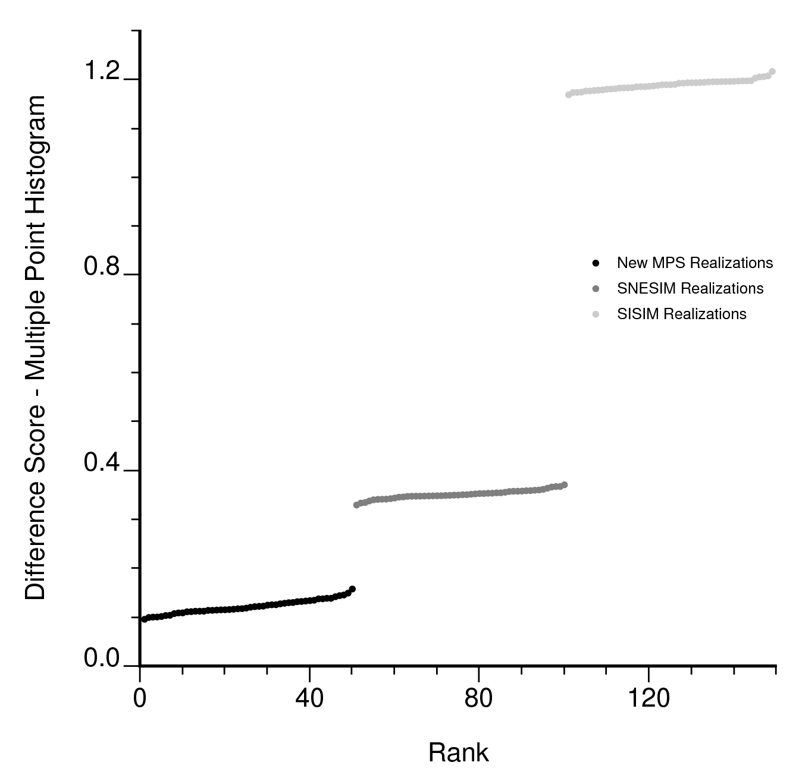
Figure 12: Ranking realizations. Left: ranking based on the runs distribution. Right: Ranking based on the MP histogram. The proposed MPS algorithm, SISIM and SNESIM realizations are compared to the TI.

ConclusionS
A workflow has been proposed to construct training images (TI) for vein type mineral deposits and then use them to infer high-order relations for use in MPS simulation. Comparisons of realizations using statistics beyond second-order moments have also been shown. The results are promising; comparing the MPS of the realizations generated using the proposed algorithm to the public-domain SNESIM program show that the realizations generated with the proposed algorithm are similar to the parent TI. Reproducing the MPS of the initial TI amounts to reproduce the nonlinear features of the parent TI.

The workflow presented could be used to improve geologic models in the future; for deposits with nonstationary features such as distinct ore/waste or high/low grade material this technique could result in better characterization of the geologic features as well as the uncertainty in the rock type model. Quantification of uncertainty is becoming very important as more stringent guidelines are being placed on reporting reserves; all possible sources of uncertainty must be considered in order to properly express the full uncertainty in the resource contained in a deposit.

References
Caers, J., 2001. Geostatistical Reservoir Modeling Using Statistical Pattern Recognition: Journal of Petroleum Science and Engineering, v. 29 (3), p. 177-188.
Deutsch, C. V., FLOWSIM: 1987. www.ualberta.ca/~cdeutsch/ accessed March 20, 2006.
Deutsch, C. V., 1992. Annealing Techniques Applied to Reservoir Modeling and the Integration of Geological and Engineering (Well Test) Data: Ph.D. Thesis, Stanford University, 304 p.
Deutsch, C. V., 1998. Cleaning Categorical variables (lithofacies) realizations with maximum a-posterior selection: Computers & Geosciences, v. 24 (6), p. 551-562.
Geman, S. and Geman, D., 1984. Stochastic Relaxation, Gibbs Distributions, and the Bayesian Restoration of Images: IEEE Transactions on Pattern Analysis and Machine Intelligence, no. 6, p. 721-741
Guardiano, F. B., and Srivastava, R. M., 1993. Multivariate Geostatistics: Beyond Bivariate Moments: Soares, A., Editor, Geostatistics Troia ’92, v. 1, p. 133-144.
Guilbert, J. P. and Park, C. F. Jr., 1996. The Geology of Ore Deposits: New York, W. H. Freeman and Company, 985 p.
Metropolis, N., Rosenbluth, A. W., Rosenbluth, M. N., Teller, A. H., and Teller, E., 1953. Equations of State Calculations by Fast Computing Machines: Journal of Chemical Physics, v. 21 (6), p. 1087-1091.
Srivastava, R. M., 2002. Nuclear Waste Management – Probabilistic Discrete Fracture Network Models for the Whiteshell Research Area: 181 p.
Strebelle, S., 2002. Conditional Simulation of Complex Geological Structures Using Multiple-Point Statistics: Mathematical Geology, v. 34 (1), p. 1-21.

